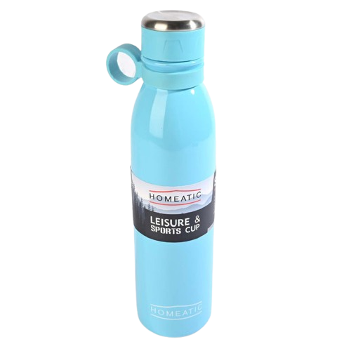

**Product details**

**Homeatic Water Bottle**

**Price: $49.99**

**Stay Hydrated, Stay Fresh.**

**The Homeatic Water Bottle is your ideal companion for hydration on the go. Featuring a sleek, ergonomic design, this bottle keeps your drinks cold for hours. Made from high-quality, eco-friendly materials, it's perfect for daily use at school, work, or the gym.**

.

**THANK YOU!**

**WELLCOME TO OUR WEBSITE**